**TITLE:** Combining field surveys, aerial photography, and simulation modelling to quantify status and trends in the vegetation of Isle Royale National Park, as it relates to forest succession, wolf predation, herbivory by moose and beaver, and climate change

**USGS PRINCIPAL INVESTIGATORS:** Nathan R. De Jager and Andrew Strassman, USGS Upper Midwest Environmental Sciences Center, 2630 Fanta Reed Road, La Crosse, WI 54603; Ph: 608-781-6232; [ndejager@usgs.gov](mailto:ndejager@usgs.gov)

**NPS POINT OF CONTACT (POC):** Mark C. Romanski, Division Chief-Natural Resources, Isle Royale National Park, 800 East Lakeshore Drive, Houghton, MI 49931; Ph: 906-487-7154; [mark_romanski@nps.gov](mailto:mark_romanski@nps.gov)

**NPS REGIONAL NRPP CONTACT:** Midwest – Julie Stumpf; Ph: 219-395-1522; [Julie_stumpf@nps.gov](mailto:Julie_stumpf@nps.gov)

**PARTNERSHIPS AND ROLES:**

This project will extend ongoing research and modelling efforts conducted by investigators at the USGS Upper Midwest Environmental Sciences Center (UMESC). All funds will be directed to the UMESC to support research activities. In addition, some travel and lodging expenses will be covered by Isle Royale National Park to support field reconnaissance. The UMESC will provide $6000 of in-kind funds to support research efforts.

Additional collaborative support for research will be provided by Lynette Potvin (Biologist, Isle Royale National Park), Mark C. Romanski (Chief of Natural Resources, Isle Royale National Park), Suzanne Sanders (Ecologist, NPS Great Lakes Inventory and Monitoring Network), Jessica Kirschbaum (Botanist, NPS Great Lakes Inventory and Monitoring Network) and Al Kirschbaum (NPS Great Lakes Inventory and Monitoring Network).

**PARK STATEMENT OF NEED ADDRESSED:** Quantifying status and trends in vegetation at Isle Royale National Park, USA as they relate to beaver and moose browsing, forest succession, and climate change.

**PROJECT NUMBER:** 2019-21

**PROBLEM STATEMENT AND IMPLICATIONS:**

In response to a decade-long decline in the wolf population of Isle Royale National Park, ultimately resulting in just two wolves remaining, the National Park Service began reintroducing wolves to the island over the past winter. Although a number of factors were considered when determining whether to reintroduce wolves, the long-term and large-scale effects of rising moose and beaver populations on the island’s vegetation were the most important factors (NPS 2017).

Isle Royale is internationally recognized for its populations of wolves and moose (Peterson et al. 2014). Despite effects of predation on the moose population, both the short and longer-term impacts of moose browsing can be seen across the island (Fig. 1). However, a number of factors may interact with moose browsing to shape the vegetation of Isle Royale National Park (e.g., forest successional processes, herbivory by beaver, and effects of a changing climate). Yet no studies have quantified the extent to which the island’s vegetation has been shaped by these factors. The lack of empirical support for how the vegetation of Isle Royale relates to the effects of wolf predation in combination with such other factors is problematic given the logistical challenges associated with wolf relocation, the high degree of uncertainty about the effects of climate change (Duveneck et al. 2014) and the potential for wildlife biologists to overestimate the effects of predation on ecosystems (Mech 2012). There is a clear need for studies that shape a comprehensive understanding of the controls over Isle Royale’s vegetation and a further need to effectively communicate such an understanding to Park managers, wolf biologists, and visitors.

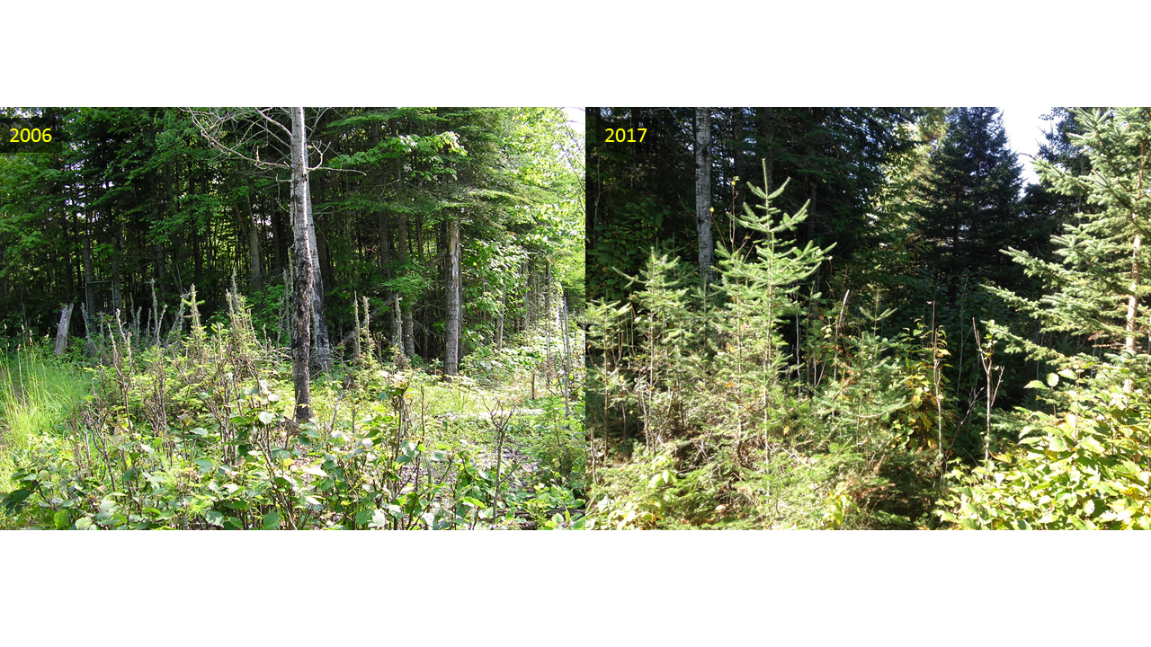

Figure 1. A moose exclosure at Isle Royale National Park showing the long-term effects of moose browsing (inside versus outside of the fenced area in 2006 and 2017) and the shorter-term effects of the lack of moose browsing due to a decade of low moose population density (outside of fenced area in 2006 vs. outside of fenced area in 2017).

It is not possible to disentangle all of the factors that might influence patterns of vegetation change over large landscapes with traditional experimental approaches or by conducting observational studies on their own. However, when combined with landscape-scale simulation models, experiments and observational studies can help to foster a more integrated understanding. By using simulation models to evaluate hypothetical scenarios, researchers can isolate the possible effects of one or more factors while holding others constant. When model results are compared with results from manipulative experiments or observational studies, it becomes more likely to sort out when and where certain factors are most likely to be responsible for vegetation change.

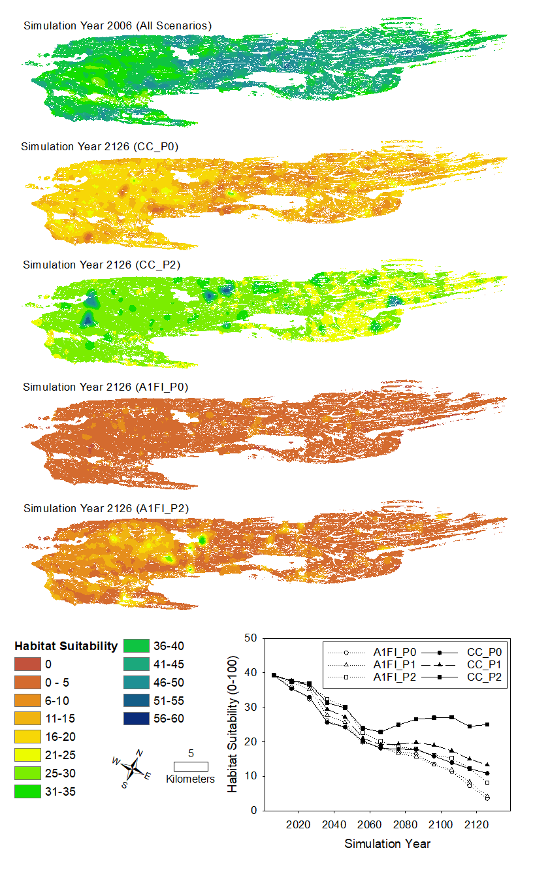For example, over the past few years we have developed a state of the art spatial simulation model that links forest successional processes, moose population dynamics, and effects of moose browsing on the vegetation of Isle Royale National Park. Our work has helped to better understand the potential for wolf reintroduction to modify rates and patterns of moose browsing and associated changes in vegetation and the island’s ability to support a moose population over the long-term (~100 years) (De Jager et al. 2017a and b). Simulations conducted without moose browsing provided a prediction of what the future forests of Isle Royale might look like given natural forest successional processes (De Jager et al. 2017a). These simulations point to changes from early successional communities (e.g., birch and aspen forests) to late successional communities (e.g., spruce and fir forests). Additional simulations conducted with increasing wolf predation rates provided predictions of what the forests might look like given both natural forest successional processes and changing rates in moose browsing pressure (De Jager et al. 2017b). Our main findings were that browsing can accelerate the rate of forest succession, especially when wolf predation rates are low, because moose preferentially feed on early successional species such as birch and aspen and avoid late successional species. However, because moose also feed heavily on balsam fir, the shift from early successional species to late ones was dominated by shifts to white and black spruce, species that moose do not eat. The net result of accelerated forest successional changes is a drastic reduction in the potential for Isle Royale to support a moose population over the long-term (~100 years) in the absence of wolf predation. Perhaps most importantly, scenarios that included high rates of wolf predation resulted in similar forest successional patterns as observed when simulating no moose population at all, suggesting that wolf reintroduction could create forest conditions that balance management objectives related to wolf and moose populations with objectives related to healthy and sustainable forests. These findings were included in the Park’s Environmental Impact Statement as a primary motivation to reintroduce wolves to Isle Royale (NPS 2017).

Figure 2. Map outputs from model simulations including effects of predation by wolves on patterns of moose browsing and the effects of climate change on habitat suitability for moose at Isle Royale National Park. All scenarios utilized the same initial landscape (c. 2006, top panel). Outputs following simulated 120 year periods are shown for CC_P0 (current climate, no predation by wolves), CC_P2 (current climate, strong predation by wolves), A1FI_P0 (high emissions climate change scenario, no predation by wolves), and A1FI_P2 (high emissions climate change scenario, strong predation by wolves). Over the long-term, predation by wolves is projected to have little impact on habitat suitability for moose given the effects of climate change on the boreal plant communities that moose depend on (De Jager et al. In Prep).

More recently, we expanded our modelling work to explore how climate change might interact with wolf predation and moose browsing to alter the future forests of Isle Royale (De Jager et al., In Prep). Our results are revealing that the interactive effects of wolf predation and climate change are temporally variable and dependent on forest successional processes. During the first 50 years of model simulations, when the effects of climate change were minor, increased rates of predation by wolves reduced peak moose population densities and maintained higher carrying capacities for moose. During this same period, early successional and highly palatable aspen and birch forests transitioned to late successional spruce forests, regardless of climate change. Beyond 50 years, the effects of climate change and predation were driven by effects on balsam fir, a late successional species that is both highly palatable to moose and very sensitive to changes in temperature and precipitation. High rates of predation by wolves on moose allowed balsam fir to persist over the long-term, but only under the current climate scenario. Climate change caused a reduction in balsam fir and the island’s ability to support moose, regardless of predation. Our results suggest that with the simulated forest successional trajectory of Isle Royale and in the face of climate change, predation by wolves will play a diminishing role in terms of moose population and forest ecosystem dynamics over the next 100 years. It is possible that the effects of climate change will create an unsuitable habitat for moose and wolves over the long-term (Figure 2).

Despite all we have learned about the vegetation of Isle Royale and the potential for different factors to alter long-term successional patterns via modelling studies, we have yet to compare model outputs with empirical data to identify how and where the forests are changing and what the main drivers of such changes might be. Further, herbivory by beaver has not been accounted for in our modelling efforts, despite local observations suggesting that their impacts on riparian vegetation may be substantial. Finally, as we continue to incorporate additional factors (e.g., moose browsing, climate change, beaver herbivory) into our model, it will become increasingly important to find ways to effectively communicate the ever-increasing suite of model outcomes to Park managers in ways that help them make more informed decisions.

**OBJECTIVES:**

The studies outlined below will help us further develop a modelling framework that integrates ecological concepts, experimental results, and observational data sets to forecast future environmental conditions under a changing climate and alternative management scenarios at Isle Royale National Park. Our long-term approach to improving problem solving at Isle Royale is consistent with ‘futures studies’, which aim to aid decision making by adaptively improving experimental designs and long-term monitoring studies to generate data that addresses key uncertainties in model parameters and methods (Coreau et al. 2009). In particular, we seek to accomplish three main tasks: **1) combine existing vegetation data (c. 1996-1998) with available satellite data (Landsat 5,7, 8 imagery, 1986-2018), and high resolution aerial photography to map changes and quantify current vegetation conditions across Isle Royale as they relate to forest successional processes, climate change, moose browsing, and/or herbivory by beaver; 2) compare and contrast the empirical results from objective 1 with model simulations that isolate effects of a) forest succession, b) climate change, c) moose browsing, and d) beaver herbivory; 3) develop a publicly-available online story map to display vegetation maps, maps of vegetation change, along with simulation modelling outcomes to more effectively communicate the results of studies and modelling efforts to Park managers, the public, and wolf biologists.**

**STUDY AREA AND METHODS:**

The study area for our data analysis and modelling efforts will remain the main island of Isle Royale National Park and moose-accessible smaller islands. Each of our three main tasks will be accomplished via the methods outlined below.

*Task 1: Investigate changes in vegetation and quantify current conditions at Isle Royale*

We will utilize several data sets to provide a quantitative and systematic representation of current (ca. 2018) vegetation conditions at Isle Royale National Park and how those conditions have changes since 1986. The last comprehensive vegetation survey of Isle Royale was conducted from 1996-1998 (TNC 1999), resulting in the only island-wide map of vegetation communities. Our first objective will be to examine associations between spectral indices derived from Landsat data (e.g., Normalized Difference Vegetation Index (NDVI, Rouse et al. 1974) and Tasseled Cap Brightness (TCB), Greenness (TCG), and Wetness (TCW) (Crist 1985)) and the mapped vegetation communities of Isle Royale for 1996 following similar methods as outlined by Adams et al. (2019) and Pasquarella et al. (2018). Our second objective will be to quantify how various spectral indices have changed over time within the different vegetation communities at Isle Royale. For example, preliminary analyses suggest that the vegetation communities at Isle Royale may differ by the TCG index (Fig. 3) and further, that this index has been changing within different plant communities over time, suggesting that some forest communities may be succeeding to different communities.



Figure 3. Average pixel values for Tasseled Cap Greenness, showing that deciduous communities tend to support higher values of greenness than mixed deciduous conifer or conifer forests. Further, that some communities are increasing or decreasing in greenness, suggesting the possibility of successional changes.

Our third objective within the first task will be to utilize newly acquired aerial photography for the year 2018 to verify the types and locations (Fig 4) of changes we are observing in the Landsat data time series. We will further use existing data sets on locations of active beaver colonies to relate the types and locations of changes to potential impacts of beaver.

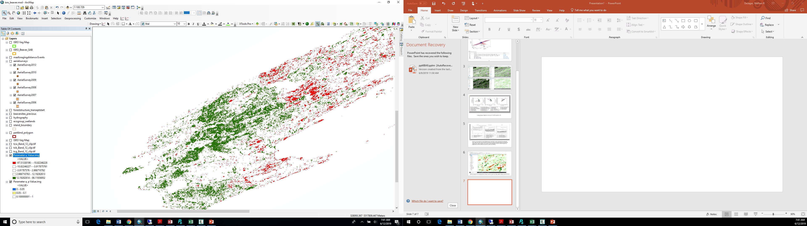

Figure 4. An image of the western portion of Isle Royale National park, showing locations of significant increases in Tasseled Cap Greenness (green, forests potentially becoming more deciduous) and other areas displaying significant negative trends in greeness (red, forests potentially becoming more coniferous).

Collectively, these analyses will help us better understand rates, magnitudes, and locations of past vegetation changes across Isle Royale National Park, identify some of the major factors influencing vegetation change (e.g., successional changes vs climate change vs animal impacts), and better quantify current conditions across the island.

*Task 2: Update/revise spatial simulation model*

Our second task will be to compare empirical maps of vegetation change with maps resulting from forest simulation modelling. This will help us validate model outcomes as well as better understand where and how different factors might be influencing the vegetation of the island. One factor that we suspect is important in riparian areas is herbivory by beaver. Whereas moose forage on small understory trees, causing long-term changes in vegetation, beaver selectively harvest large over-story trees and therefore have the potential to cause immediate changes in vegetation. We intend to use existing data to quantify the degree of selectivity by beaver on various tree species and ages, as well as determine maximum foraging distances from active beaver lodges. This information can then be incorporated into our simulation model to evaluate how forest successional changes relate to beaver activity.

Upon revising and updating the spatial simulation model, we will conduct a simulation modelling experiment to attempt to isolate the effects of a) moose browsing, b) climate change, c) beaver herbivory, and d) natural forest successional changes, as well as how these factors interact with each other to influence vegetation changes and habitat suitability for moose over 100-year periods. These model results can be compared with results from our empirical investigations to better shape a comprehensive understanding of when and where various factors influence the vegetation of Isle Royale National Park.

*Task 3: Develop online story map*

Although spatial simulation modelling is a powerful tool for investigating landscape-scale changes in vegetation, it is often very difficult for resource managers and/or the public to understand how model outputs relate to conditions in the field. Published papers are often inadequate for communicating the results of spatial models, given the large number of output files generated by models and journal requirements for as few figures as possible.

In an effort to bridge this gap we will create a publicly-accessible online story map showing how herbivory by moose and beaver interact with wolf populations over time to effect vegetation on Isle Royale. A story map is an online, interactive, publicly accessible web page that provides a story of the data using related photos, maps, charts, and graphs. For the Isle Royale herbivory – vegetation – predation connection story map we envision a story map outline of how vegetation composition on the island has changed over the past several decades. Along with empirical data, we will provide model outputs of various simulations to illustrate the potential effects of different factors (e.g., moose, beaver, climate change) and how they may interact with each other. Imbedded within this story map will be 360 degree images taken at Isle Royale, to better connect aerial photos and map outputs with on-the-ground conditions. Infographics on the interaction of wolves, moose, and beaver will also be used to show the interrelatedness of these hard-to-conceptualize connections, which are critical to understanding the dynamic nature of the vegetation of the Park.

**SPECIAL PROVISIONS:** This project (or protocol) is fully covered by an established Categorical Exclusion from the NEPA process.

**SAFETY:** There are no known job hazards associated with this project.

**PROJECT DURATION/SCHEDULE:**

We anticipate completing two peer-reviewed manuscripts for publication in scientific journals with drafts available at or before the end of 2020 and 2021. In addition, the online story map will be delivered as soon as possible, but not later than September 2021. Any data created by USGS will be made available via the USGS Science Data Catalogue.

**DELIVERABLE PRODUCTS:**

September 30, 2019: Progress briefing on data analysis and initial story map developed

September 30, 2020: Draft manuscript including results from empirical analyses of vegetation change and current conditions at Isle Royale. Data added to story map.

March 31, 2021: Draft of complete story map to park for review.

September 30, 2021 Draft manuscript of spatial simulation model results. Final story map published and publicly accessible.

**LITERATURE CITED:**

Adams, B.T., et al. 2019. Mapping floristic gradients of forest composition using an ordination-regression approach with landsat OLI and terrain data in the Central Hardwoods region. Forest Ecology and Management. 434: 87-98.

Crist, E. P., 1985, A TM tasseled cap equivalent transformation for re ectance factor data. Remote Sensing of Environment, 17, 301–306

Coreau, A. et al. 2009. The rise of research on futures in ecology: rebalancing scenarios and predictions. Ecology Letters 12: 1277-1286.

De Jager, N.R., Drohan, P.J., Miranda, B.M., Sturtevant, B.R., Stout, S.L., Royo, A.A., Gustafson, E.J., Romanski, M.C. 2017a. Simulating ungulate herbivory across forest landscapes: a browse extension for LANDIS-II. Ecological Modeling 350:11-29.

De Jager, N.R., Rohweder, J.J., Miranda, B.R., Sturtevant, B.R., Fox, T.J., Romanski, M.C. 2017b. Modelling moose-forest interactions under different predation scenarios at Isle Royle National Park, USA. Ecological Applications 27: 1317–1337.

De Jager, N.R., Rohweder, J.J., Duveneck, M.J. In Prep. Interactive effects of wolf predation and climate change on moose-forest interactions at Isle Royale National Park, USA.

Duveneck, M. J., R. M. Scheller, M. A. White, S. D. Handler, and C. Ravenscroft. 2014. Climate change effects on northern Great Lake (USA) forests: a case for preserving diversity. Ecosphere 5:article 23.

Mech, L.D. 2012. Is science in danger of sanctifying the wolf? Biological Conservation 150: 143-149.

National Park Service. 2017. Environmental Impact Statement to Address the Presence of Wolves at Isle Royale National Park. [ISRO_Wolf_FEIS_March_2018_508_final.pdf](https://parkplanning.nps.gov/showFile.cfm?projectID=59316&MIMEType=application%252Fpdf&filename=ISRO%5FWolf%5FFEIS%5FMarch%5F2018%5F508%5Ffinal%2Epdf&sfid=317805)

Pasquarella, V.J., Holden, C.E., Woodcock, C.E., 2018. Improved mapping of forest type using spectral-temporal Landsat features. Remote Sens. Environ. 210, 193–207.

Peterson, R.O., J.A. Vucetich, J.M. Bump, and D.W. Smith. 2014. Trophic cascades in a multicausal world: Isle Royale and Yellowstone. Annual Review of Ecology, Evolution, and Systematics. 45: 325-345.

Rouse, J. W., Haas, R. H., Deering, D. W. & Sehell, J. A., (1974): Monitoring the vernal advancement and retrogradation (Green wave effect) of natural vegetation. Final Rep. RSC 1978-4, Remote Sensing Center, Texas A&M Univ., College Station.

The Nature Conservancy. 1999. USGS-NPS Vegetation Mapping Program: Classification of the Vegetation of Isle Royale National Park.

